What is a token?
- AI models (like ChatGPT, Claude, or Gemini) do not read text as whole words like humans do. Instead, they break text / image down into small chunks (Tiles for image) called tokens.
Text
- A token is not always a word
- The Golden Rule of Thumb:
  - 1,000 tokens ≈ 750 words, roughly 4 characters per token in English

Text Input | Token Count | Why?
"The cat sat." | 4 tokens | "The", " cat", " sat", "." (spaces count!)
"12345" | 1–3 tokens | Digits are often split (e.g., 12, 345).
"🙂" | 1–3 tokens | Emojis are complex byte sequences.
Image
- The "Tile" Concept
  - Imagine placing a grid of 512x512 pixel sticky notes over your image.
    - 1 sticky note (Tile) = A fixed cost (usually 170 tokens).
    - Base Cost: You pay a small fee (85 tokens) just for sending the image
Image Size | Resolution | Tiles Needed | Token Cost | Price (at $2.50 / 1M)
Small | 512 x 512 | 1 tile | 255 | ~$0.0006
Square | 1024 x 1024 | 4 tiles | 765 | ~$0.0019
Full HD* | 1920 x 1080 | 6 tiles | 1,105 | ~$0.0028
Low Detail | Any Size | N/A | 85 | ~$0.0002

Token Cost Calculation
Text
- Input Tokens (Cheap): What you send to the AI (your prompts, documents you upload).
- Output Tokens (Expensive): What the AI writes back to you. Output is usually 3x–5x more expensive than input.

Image
2 Main Formulas
- OpenAI Method
  - Tokens = 85 (Base) + (170 × Number of Tiles)
- Anthropic Method
  - Tokens = ( Width x Height ) / 750

If Sending an Image to the AI for analyzing, it will only charge the standard Input Token rate
If Asking the AI to Create an Image, Usually $0.040 to $0.080 per image (Unit Price)



NOTE:
- Most AI services (APIs) charge you based on usage per 1 million (1M) tokens

Token Pricing Documentation
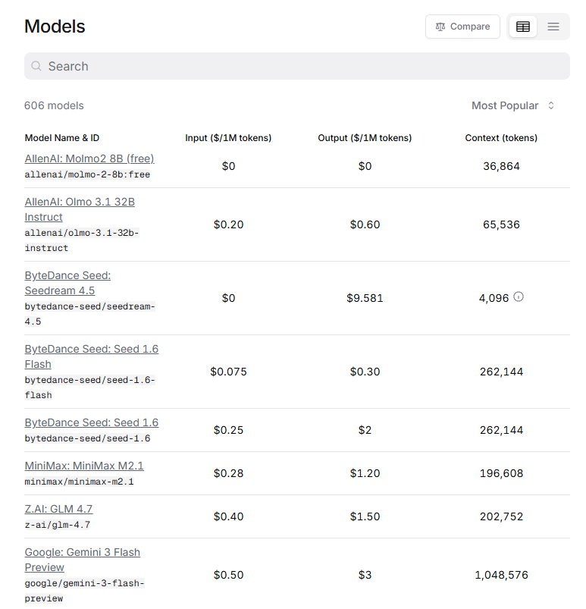
Models | OpenRouter
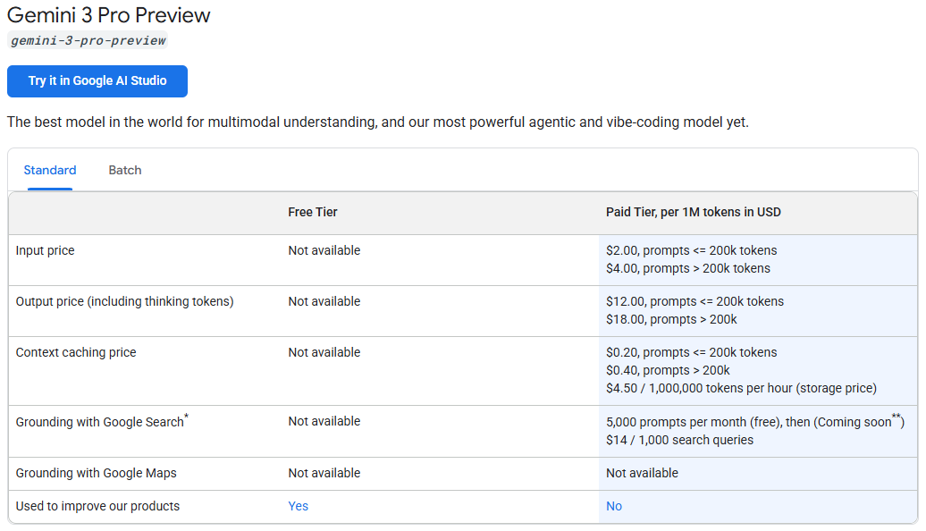
Gemini Developer API pricing

Gemini 3 Pro Preview
- Input price = RM8 ($2.00)
- Output price =RM16 ($4.00)

Example case: Imagine you want to summarize a 50-page PDF (approx. 25,000 words) into 1 page (approx. 500 words)
Step 1: Convert Words to Tokens
- Input: 25,000 words / 0.75 ≈ 33,333 tokens
- Output: 500 words / 0.75 ≈ 667 tokens
Note:
0.75 is derived from

- 1 Token ≈ 4 Characters of English text
- 1 Word ≈ 5.3 Characters (roughly 4.3 letters + 1 space)

- Words per Token = Average Characters per Token / Average Characters per Word
- Words per Token = 4 / 5.3 ≈ 0.75

- Token per word = 1 / 0.75 ≈ 1.33

Therefore: To process 1 word, will consume approx. 1.33 token

Step 2: Apply the Price (using $2.00 / $4.00 rates)
- Input Cost: (33,333 / 1,000,000) x RM8 ($2.00) = RM0.26 ($ 0.06666) (approx. 7 cents)
- Output Cost: (667 / 1,000,000) x RM16 ($4.00) = RM0.0106 ($ 0.002668) (less than 1 cent)
Total Cost: RM0.27 (Summarizing a 50-page PDF into 1 page )

References:

API Token Calculator

https://token-calculator.net/

